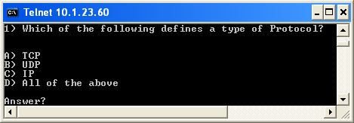

D) All of the above

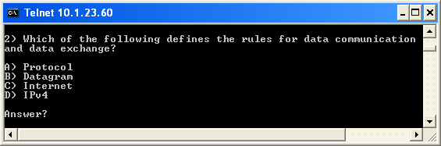

A) Protocol

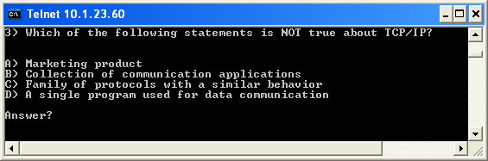

D) A single program used for data communication

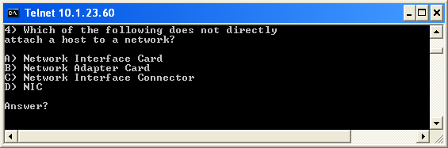

C) Network Interface Connector

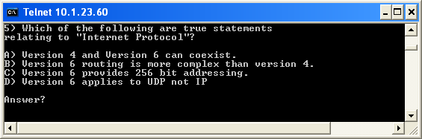

B) version 6 routing is more complex than version 4

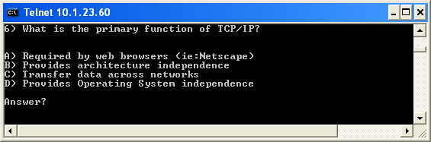

C) Transfer data across networks

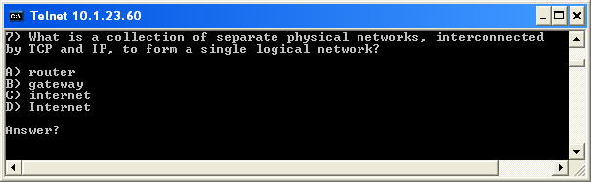

C) internet

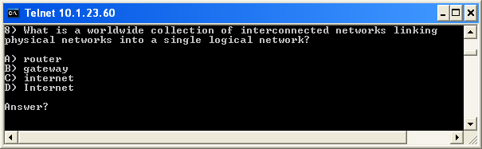

D) Internet

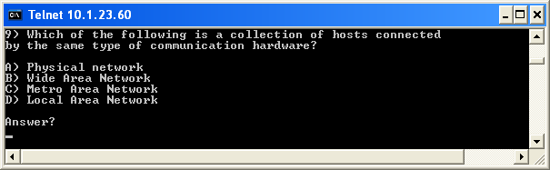

D) Local Area Network

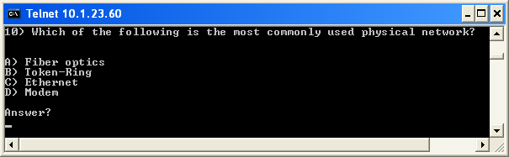

C) Ethernet

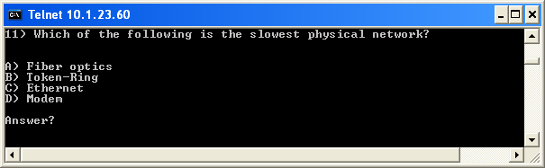

D) Modem (kbps vs. Mbps)

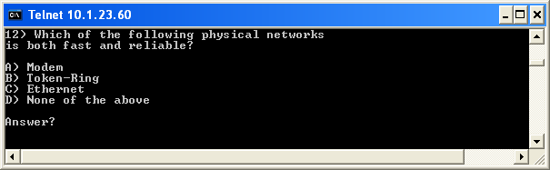

B or C) (token ring because fewer collisions, Ethernet as errors are usually isolated to a single client and faster than token ring)
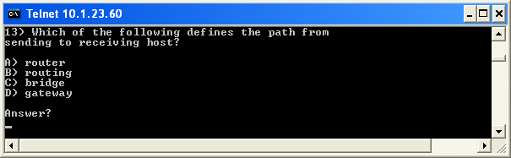

B) Routing

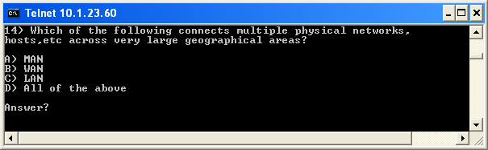

A or B) MAN or WAN (definition of large….)

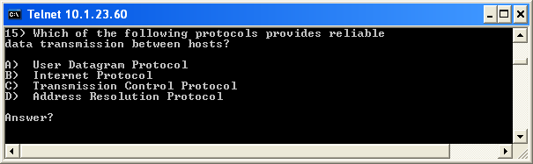

C) Transmission Control Protocol

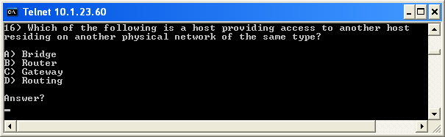

C) Router

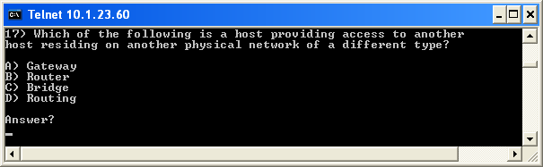

C) Bridge

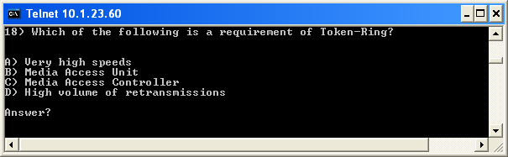

B) Media Access Unit

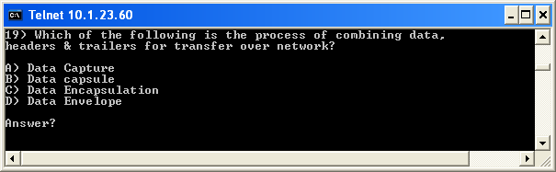

C) Data Encapsulation

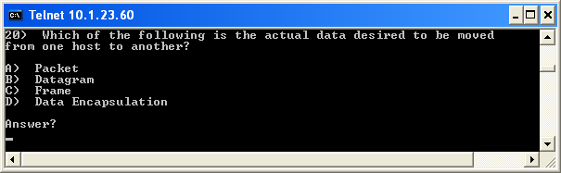

B) Datagram

